/\*\*\*\*\*\*\*\*\*\*\*\*\*\*\*\*\*\*\*\*\*\*\*\*\*\*\*\*\*\*\*\*\*\*\*\*\*\*\*\*\*\*\*

\* Excercise 73015 \*

\* Maxwell Stephens \*

\* 12:30 TTh \*

\* 4/19/17 \*

\*\*\*\*\*\*\*\*\*\*\*\*\*\*\*\*\*\*\*\*\*\*\*\*\*\*\*\*\*\*\*\*\*\*\*\*\*\*\*\*\*\*\*/

/\*

A program that allows a user to book 28 seats on a flight.

There are 7 rows and 4 columns of seats.

After the flight is booked the program tells the user the flight is full.

\*/

#include <iostream>

#include <string>

using namespace std;

int main() {

//declare vars

int rowNumber;

int totalBookings = 0;

int maxBookings = 28;

int columnNumber;

char seatLetter;

bool keepBooking = true;

string answer;

string planeArray[7][5] = {

{ "1", "A", "B", "C", "D" },

{ "2", "A", "B", "C", "D" },

{ "3", "A", "B", "C", "D" },

{ "4", "A", "B", "C", "D" },

{ "5", "A", "B", "C", "D" },

{ "6", "A", "B", "C", "D" },

{ "7", "A", "B", "C", "D" }

};

while (keepBooking == true) {

//display available seats

cout << "Available seats:" << endl;

for (int i = 0; i < 7; i++) {

for (int z = 0; z < 5; z++) {

cout << planeArray[i][z] << " ";

}

cout << endl;

}

//get user seat choice

cout << "Enter row number: ";

cin >> rowNumber;

rowNumber = rowNumber - 1;

cout << "Enter seat letter: ";

cin >> seatLetter;

seatLetter = toupper(seatLetter);

cout << "Your seat is " << rowNumber + 1 << seatLetter << endl;

if (seatLetter == 'A') {

columnNumber = 1;

}

else if (seatLetter == 'B') {

columnNumber = 2;

}

else if (seatLetter == 'C') {

columnNumber = 3;

}

else if (seatLetter == 'D') {

columnNumber = 4;

}

//assign seat

if (planeArray[rowNumber][columnNumber] != "X") {

planeArray[rowNumber][columnNumber] = "X";

totalBookings++;

}

//display available seats

cout << "Available seats:" << endl;

for (int i = 0; i < 7; i++) {

for (int z = 0; z < 5; z++) {

cout << planeArray[i][z] << " ";

}

cout << endl;

}

//quit logic

if (totalBookings >= 28) {

cout << "PLANE BOOKED" << endl;

cout << "Exit? Y/N";

cin >> answer;

if (answer == "Y" || answer == "y") {

keepBooking = true;

}

else {

keepBooking = false;

}

}

//continue/quit logic

cout << "Would you like to book another seat?" << endl;

cout << "Enter Y for yes and anything else to quit: ";

cin >> answer;

if (answer == "Y" || answer == "y") {

keepBooking = true;

}

else {

keepBooking = false;

}

cout << "total bookings: " << totalBookings << endl;

}//end loop

return 0;

}

/\*

SAMPLE OUTPUT:

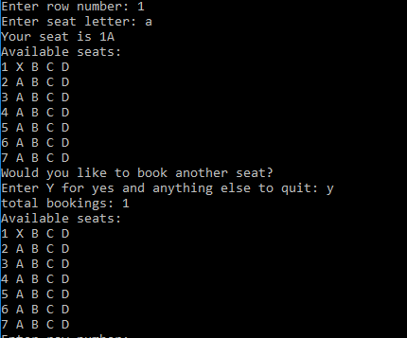

Self-Evaluation:

4: Works perfectly, code properly documented

I believe I earned 4 points.

\*/